

**Phenomenal Leadership Systems - Howard Partridge**

**Module 3 April 19th, 2016**

**Interviewing and Hiring**

The #1 Rule: Hire _____________!

The only exception is if you already know this is the ________ person in every way.

Step 1: The _____________ Process

Step 2: The _____________ Process

Step 3: The _____________ Process

__________ the Candidate

Ask ______ _________ Questions

Use the ____/____ Rule

Use the Interview Guide

Go Over ____, _____, _____ Chart, ________ and ________

Go Over ___________ Plan

Howard’s 2 Part Agreement

1. What ____ do

2. What ____ do

**“You can have everything in life you want, if you just help enough other people get what they want” – Zig Ziglar**

Step 4: The __________ Process

* Review __ __ __
* Review __ __ __
* Review ____ Chart
* Review ______ and ____________
* Review _____________ Plan
* Introduce to other team members (build people up, avoid jesting!)
* Get paperwork underway
* Schedule Orientation and Training

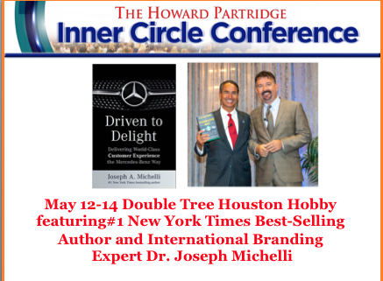

**Five Reasons to Attend…**

1. Connect with your coach – get the support you need.

2. Connect with the community – learn from each other.

3. Learn from top speakers and trainers – take your business to the next level

4. Get away from the pressure-cooker of every day life and get clarity

5. New Inner Circle VIP Rewards Program! WIN BIG!

**Inner Circle Members Attend at NO CHARGE, but You MUST Register!**

[**www.HowardPartiridgeRoundTable.com/IC**](http://www.HowardPartiridgeRoundTable.com/IC)