Customer Service Truths

1. Customers aren’t concerned about _______ problems

2. Customers respond to _________________ customer service.

3. Customers are _____ __________________.

4. Customers’ _________________ are:

- Do it _______________
- Do it _______________
- Watch my ________________

5. Customers have long ____________________.

6. Customer service starts with ________________ customers.

7. Customers’ _________________ determines customer loyalty.

“Good service leads to multiple sales. If you take good care of your customers, they will open doors you never could open by yourself.”

– Jim Rohn

Customer Service (Turn Offs)

X Inattentive behavior (______ _________________).

X Non-professional ______________________.

X Lack of _______________ (going through the ________________).

X Lack of ______________ _______________________.

X Lack of _________________________.

X Slow response (no sense of ____________________).

X ____ “personalized” service.

X Employees who _______ like they would rather be __________ but at _____________.

X __________________ not perceived.

X _________________ to other employees.

X A _______________ that is not _______________.

X Not handling ________________ properly.

X Unsatisfactory ___________ for price paid.

X Lack of _____________ for _____________ needs.

X Poor ________________ etiquette.

The Customer Service Self-Test
1 – never; 2 – rarely; 3 – sometimes; 4 – frequently; 5 – always

_____ 1. Our company is totally committed to creating satisfied customers.

_____ 2. We use technology to assist our customers in their decision
making process.

_____ 3. Serving customer needs takes precedence over internal needs.

_____ 4. Each person in our company talks to customers at least weekly.

_____ 5. We add lagniappe to our customers’ buying experience.

_____ 6. We deliver what we promise.

_____ 7. We actively seek complaints.

_____ 8. We eliminate procedures that do not add value for our customers.

_____ 9. We clearly understand what our customers expect from our
company.

_____ 10. We consistently show our customers that we care about their
business.

_____11. Our employees are experts in the products we sell.

_____ 12. We treat our employees with dignity and respect.

_____ 13. We study our competitors for ideas on how we can do things
better.

_____ 14. We study our competitors for ideas on how we can do things
better.

_____ 15. We reward customer loyalty.

Top Ten Customer (Turn On’s)

1. Treat me with _________. I am a customer, not an __________ ___________.

2. Follow through on your _______________.

3. Communicate with me about both the _________ and the ______.

4. Talk to me without _____________. ___________!

5. Answer the phone quickly... and get back to me when you _____ you will.

6. Provide ___________ when we have a _____________.

7. Allow me to talk to someone in ___________ when there is a ____________.

8. Clearly state what I should __________ from _________.

9. Know ___________ about your _________ and __________.

10. Be a customer advocate. Show ________________.

“Success is the doing, not the getting; in the trying, not the triumph. Success is a personal standard, reaching for the highest that is in us, becoming all that we can be. If we do our best, we are a success.”

– Zig Ziglar

Customer Service Excellence

Seven Essential Attitude Shifts for Quality Customer Service

1. Move from the attitude of being ___________ to the attitude of
being the recognized _____________.

2. Move from the attitude of _______________ responsibility to
________ effort.

3. Move from the attitude that customer service is someone
__________ concern to customer service is ______ concern.

4. Move from the attitude that __________ employees have
customers to the attitude that _______ employees have customers.

5. Move from the attitude of solving a _____________ to the attitude
of creating an ____________ to establishing trust in the company.

6. Move from the attitude of _________ are a cost of doing business
to you never have ___ _________ chance to make a first
impression.

7. More from the attitude of if it’s _____ __________, why fix it to the
attitude of _______________ improvement.

“One customer, well taken care of, could be more valuable than $10,000 worth of advertising.”

– Jim Rohn
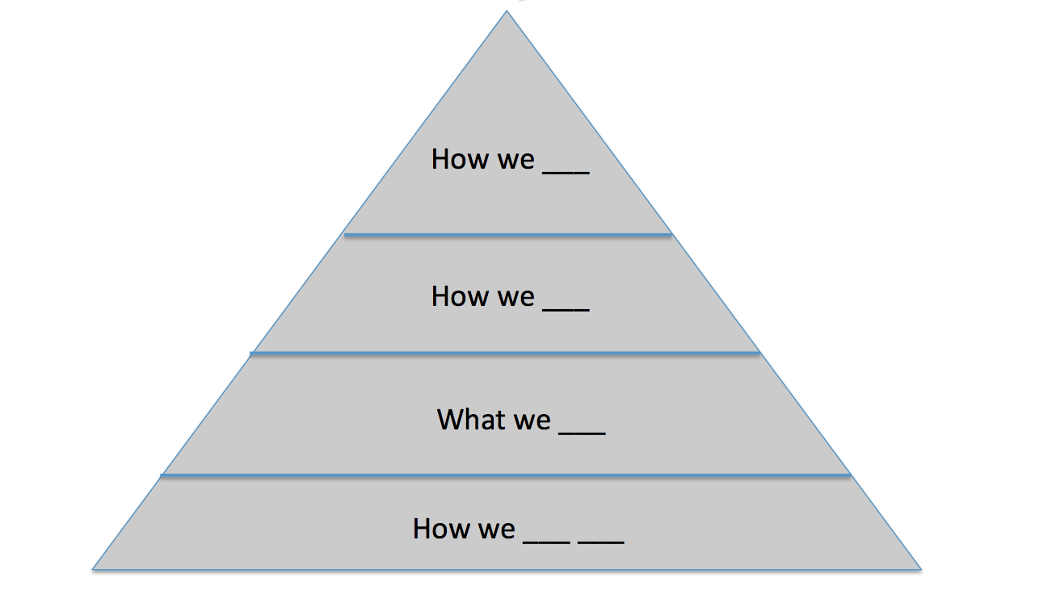
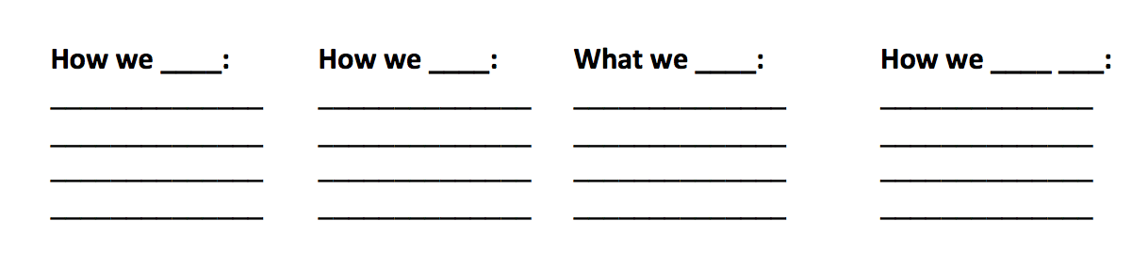

Thanks
for
Coming!
Tha-tha-that’s all folks!!!

