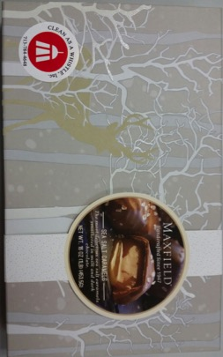**Monthly Marketing Goodies – 2014**

NOVEMBER

Central Market Pumpkin Spice Cookies or Maple Cookies - $2.99 at HEB

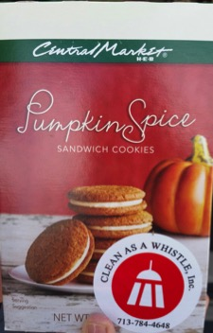

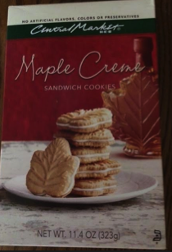

DECEMBER

Maxfield Sea Salt Caramels from SAMs Club. $10.98

(Had Christmas sticker, not regular CAAW sticker)

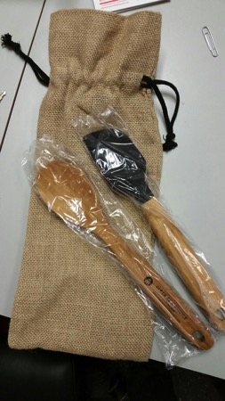

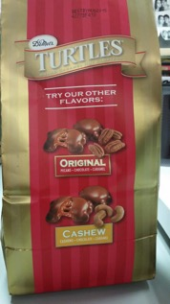Large Referral Gift 2013 & 2014

Other Goodies

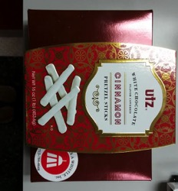

Spoons w/ CAAW information.

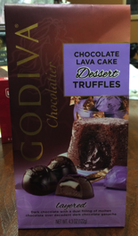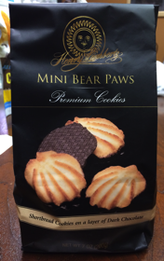

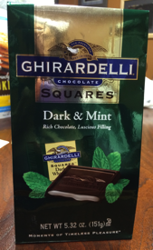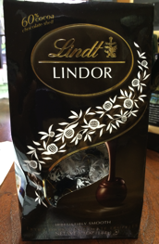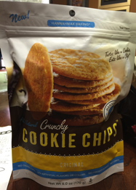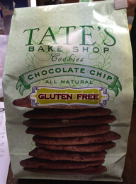

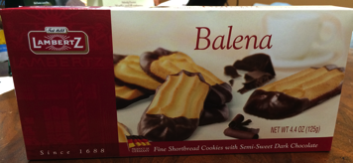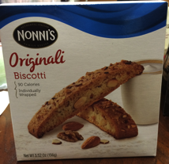

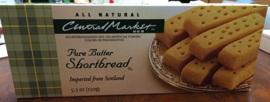

**Monthly Marketing Goodies – 2015**

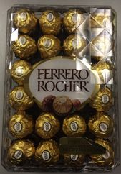

JANUARY

Planter's Nutrition Heart Healthy Mix SAMs Club.

Nuts: $7.48/ box

Ferrero Rocher: ???

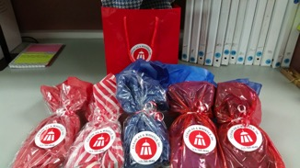

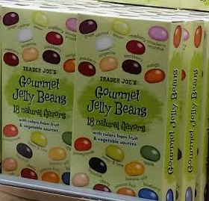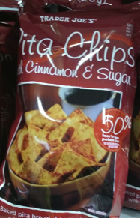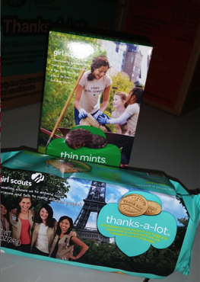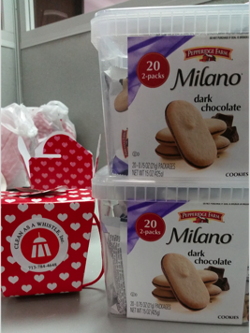

JUNE

Trader Joe’s Jelly Beans

$1.99/box (2/person)

APRIL

Cookie Chips ~ $3.99 ??? each. From HEB/ Ross

MAY

Trader Joe’s Cinnamon & Sugar Pita Chips $1.99/bag

MARCH

Girl Scout Cookies

$4 a box

** Thanks-a-lots**

FEBRUARY

Valentine Box: 2 for $1 at the Dollar Tree

Each box filled with 5 individually wrapped Milano Cookies from SAMs Club at $??? For 20.

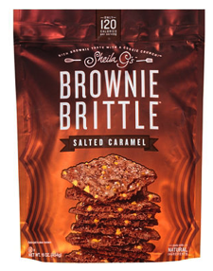

AUGUST

Brownie Brittle

JULY

HEB Brookside: Chocolate covered fruit

$3.98/bag

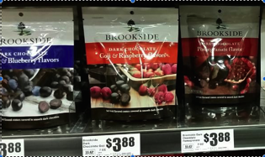

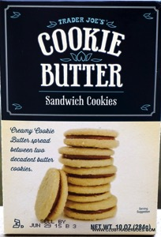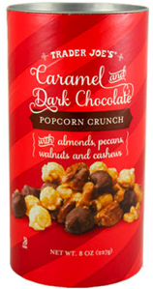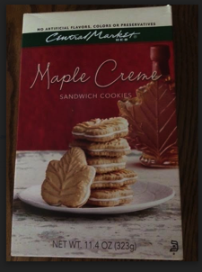

SEPTEMBER

Cookie Butter Cookies

DECEMBER

Popcorn Crunch

NOVEMBER

Maple Creme

Cookies

**Monthly Marketing Goodies – 2016**

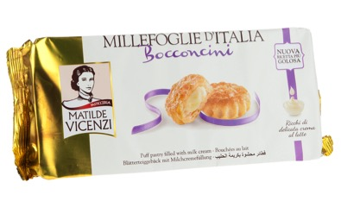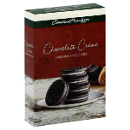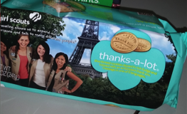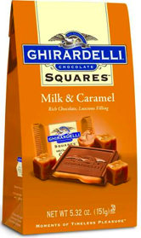

April 2016

Italian crème puffs – Millefoglie D’Italia

March 2016

Central Market – Chocolate Crème Sandwhich cookies

FEBRUARY

Girl Scout Cookies – Thanks-A-Lot

JANUARY

Ghirardelli Chocolates