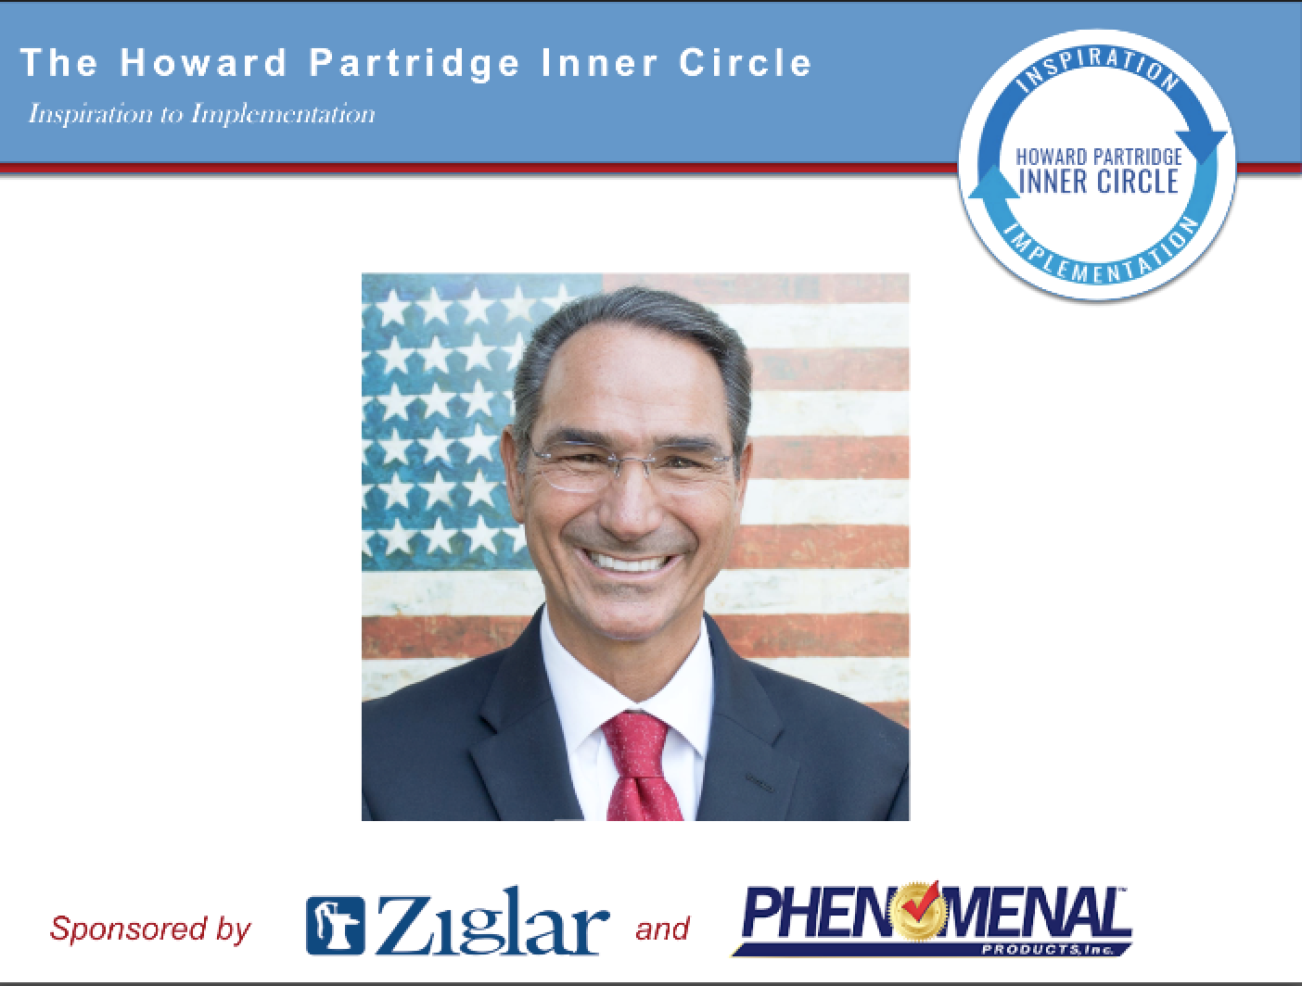
The Simple Dimple Business Plan

Updated January 24th, 2017

Company Name_______________________

Plan for Year__________ Date Plan Created _______

Step 1: My Business Vision for the Next 12 Months

Describe how you see your business being different this year. A vision is a “picture” of your preferred future. Your vision will include sales numbers, staff changes, equipment purchases, new products or services. Jus let your imagination run on this exercise. List everything you would like to do.

________________________________________________________________________________________________________________________________________________________________________________________________________________________________________________________________________________________________________________________________________________________________________________________________________________

________________________________________________________________________________________________________________________________________________________________________________________________________________________________________________________________________________________________________________________________________________________________________________________________________________

________________________________________________________________________________________________________________________________________________________________________________________________________________________________________________________________________________________________________________________________________________________________________________________________________________

Staff Changes (if any): ______________________________________________________________________________________________________________________________________________________________________________________________________________________________________________________________________________ (Update Your Org Chart)

Equipment or Resources to Add:
______________________________________________________________________________________________________________________________________________________________________________________________________________________________________________________________________________

New Initiatives (New Services, New Markets, etc.)
________________________________________________________________________________________________________________________________________________________________________________________________________________________________________________________________________________________________________________________________

Step 2: Assess Where Your Business is Now with The Born To Win Business Assessment

Rate each of the following statements on a scale of 1 – 10 as they exist in your business right now.
1=Poor. 10= Phenomenal. Then divide your total number by 10 and enter that number.
Example: 52 = 10 = 5.2

  - Marketing
- Meeting or exceeding my sales goals through effective lead generation and promotions.
- We have a clear position in the marketplace
- We have clearly defined our prime target market
- We have clear definitions of our product and/or services
- We have a pricing strategy that is profitable
- We are consistently marketing to our house list (client base)
- We have an effective referral relationship program
- We have an effective referral/affiliate reward system
- We have a written, posted marketing calendar
- We have an effective internet marketing system that includes websites(s) that clearly communicate what we do, we utilize SEO, and we are consistently capturing e-mail addresses and using them to communicate to our e-mail audience, and we have a strong presence on social media.
TOTAL ÷ 10= _____

2. Sales
- We answer the telephone live
- We have effective telephone answering/transferring systems
- We have an effective sales script that appeals to our target market and closes the
maximum number of inquiries
- We have an effective system for responding to internet leads
- We have an effective sales process for each of our profit centers
- We have an effective up-sell and down-sell process
- We have effective processes and scripts for overcoming objections
- We have an effective process for identifying ongoing and changing customer needs
- We have clearly defined account management policies and procedures
- We have effective customer management software in place
TOTAL ÷ 10= _____

3. Operations
- We have developed our unique service experience
- We have clear/cut service systems in place that are exceeding our client expectations
- We respond immediately to client concerns
- We have clear cut return/refund policies
- We get customer feedback on a regular basis to ensure we are exceeding expectations
- We have regular production meetings to ensure on time delivery
- We have a key customer appreciation process
- We have effective project management processes in place
- We have inventory management and office supplies/equipment processes in place
- We have the latest, most effective equipment to deliver our unique service experience
TOTAL ÷ 10= _____

4. Administration
- We track and report sales by profit center weekly, monthly and annually
- We track and report total sales daily
- We track and report sales by referral/affiliate/ad source weekly
- We track and report sales closings daily (# of calls vs. # of sales)
- We track and report number of returns or re-services as they occur
- We track and report our profit and loss weekly
- We track and report our balance sheet monthly
- We have a cash flow management process in place that includes systems for
Accounts Payables and Accounts Receivables
- We plan our taxes annually before year end
- We review our legal and insurance exposure annually (or as often as required)
TOTAL ÷ 10= _____

5. Leadership
- We have a one sentence mission statement that everyone understands and follows
- We have effective management systems in place that includes recruiting, hiring, orientation, training, coaching, employee reviews and termination processes and have ensured they are legal.
- We have an up to date employee handbook
- We have a written business plan that includes our vision, goals, a marketing plan, sales plan, operating plan and administration plan that is reviewed and updated quarterly.
- We have a written and posted organizational chart
- We have regular team meetings
- We have written position descriptions for every position
- We have a training system in place for every position
- We have policies and procedures for all areas of our business
- We have an effective compensation plan in place that includes attractive pay and benefits that create high employee morale and retention.
TOTAL ÷ 10= _____

Circle the number on the corresponding spoke,
then draw a curved line connecting the dots.

When your business wheel isn’t balanced it makes
for a rough ride. Get your business balanced,
and you’ll go smoother down the road.

Make your wheel a 10 all the way around
and you’ll have a phenomenally successful business!

Step 3: S.W.O.T. Analysis

According to the Business Assessment, fill in the S.W.O.T. Analysis

Strengths of my business: ________________________________________________________________________________________________________________________________________________________________________________________________________________________________________________________________________________________________________________________________________________________________________________________________________________
________________________________________________________________________________________________________________________________________________________________________________________________________________________________________________________________________________________________________________________________________________________________________________________________________________

Weaknesses of my business: ________________________________________________________________________________________________________________________________________________________________________________________________________________________________________________________________________________________________________________________________________________________________________________________________________________
________________________________________________________________________________________________________________________________________________________________________________________________________________________________________________________________________________________________________________________________________________________________________________________________________________

Opportunities I need to take advantage of this year: ________________________________________________________________________________________________________________________________________________________________________________________________________________________________________________________________________________________________________________________________________________________________________________________________________________
_____________________________________________________________________________________________________________________________________________________________________________________________________________________________________________________________________________________________________________________________________________________________________________________________________________

Threats that could damage my business that I need to be aware of:
________________________________________________________________________________________________________________________________________________________________________________________________________________________________________________________________________________________________________________________________________________________________________________________________________________
________________________________________________________________________________________________________________________________________________________________________________________________________________________________________________

Step 4: Set Your Sales Goal and 12 Month Financial Forecast

Follow the directions on the Inner Circle website under Administration to create your 12 month financial forecast. Attach to this plan.

The “simple-dimple” thumbnail budget: 1. Determine what Net Income you want. This is the amount you need before taxes to reinvest in your business and to compensate yourself. 2. Determine what your Fixed Expense is. Add your Net and your Fixed Expense to get your Gross Profit. 3. Determine the % of Sales your Gross Profit is running now and divide Gross Profit by that %. Example: If your Gross Profit is 55%, take the Gross Profit and divide by .55

 | $_______________ | Sales (All Revenue)
- | $_______________ | Cost of Services Sold (COGS)
= | $_______________ | Gross Profit (GP)
- | $_______________ | Fixed Expense (Overhead)
= | $_______________ | Net

My
12 Month
Budget

Step 5: G.P.S.

Goal $___________________ (put your sales goal for the year here and add any notes that you need to stay focused)

Priority 1:

(This first priority is your ONE Thing: “What’s the ONE Thing we can do to reach our goals goal, such that by doing it, everything else becomes easier or unnecessary?”)

Strategies (outline the systems, strategies and projects required to make this priority a reality in your business this year)
Strategy 1:
Strategy 2:
Strategy 3:
Strategy 4:
Strategy 5:

Priority 2:

Strategy 1:
Strategy 2:
Strategy 3:
Strategy 4:
Strategy 5:
Priority 3:

Strategy 1:
Strategy 2:
Strategy 3:
Strategy 4:
Strategy 5:

Step 6: Create Your M.V.P. (Mission, Values and Purpose)

Our Mission: Create a one sentence Mission Statement that describes WHAT you and your team must do each day to accomplish the vision. Example: “Provide the Most Phenomenal Service Experience Ever” or “Create the Most Phenomenal Community Experience Ever”
________________________________________________________________________________________________________________________________________________________________________________________________________________________________________________________________________________________________________________________________

Our Values: Create 3 to 5 Values that describe WHO you and your team need to be accomplish the mission. Example: Reputation (we must demonstrate trust), Experience (we must gain experience in all aspects of our industry), Education (we must train ourselves thoroughly to accomplish the mission), Systems (we must operate by systems rather than making it up every day to accomplish the mission), Guarantee (we guarantee our work 100% if we do not accomplish the mission). Values could also be integrity, honesty, character, thinking big, the golden rule, etc.
________________________________________________________________________________________________________________________________________________________________________________________________________________________________________________________________________________________________________________________________

Our Purpose: Create a one sentence Purpose Statement that explains WHY your company matters to your community. Example: “To Help Small Business Owners Have More L.I.F.E. (Live In Freedom Everyday)” or “To Protect Our Community from Unscrupulous Service Companies”
________________________________________________________________________________________________________________________________________________________________________________________________________________________________________________________________________________________________________________________________

Step 7: Organizational Chart Describe the positions in your company and place them in the appropriate boxes. Then put the initials of the person(s) that fill that role. What boxes will you get out of this year? What staff changes will you make?
LEADERSHIP | MARKETING | SALES | OPERATIONS | ADMINISTRATION
Directing
(Planning)
Managing
(Supervising)
Implementing
(Doing)

Step 8: Create Your Performance Results Descriptions (PRD)

Create a PRD for each Position on the Organizational Chart. See Inner Circle Online Training/Leadership to learn about PRDs and to download the document.

(Insert your PRD into your binder)

Step 9: Create Your Phenomenal Marketing Plan with the “7Ms” of Marketing

1. Marketing Mindset: (What happens when you don’t market your company properly? Notate WHY it is so important for you to aggressively market your company. What are the benefits of implementing your marketing consistently?)

Notate how you need to change your mindset in order to make sure you have a consistent flow of the right prospects.

Attach your sales reports: Sales by Category and Sales by Source. You’ll need this tracking to set your goals. ________________________________________________________________________________________________________________________________________________________________________________________________________________________________________________

2. Mission: (keep your mission in mind as you are doing your marketing plan). Restate your mission again here) ________________________________________________________________________________________________________________________________________________________________________________________________________________________________________________

3. Money: Break Down Your Company Sales Goal.
1. Take your Sales Goal from Step 4 and fill in here: $__________________
2. Break it down by the month: $____________________ per month (Average). Once you study
your history, you can adjust your months up and down depending on seasonality.
3. Break it down by the week: $_____________________ (per week).
4. Break it down by the DAY: $_________________ (per day).
5. Track the Daily Sales Goal with your team every day.
Marketing Investment: Determine how much you will commit to your marketing.

$_______________________ (Per Year) $_______________________ (Per Month)

4. Market: Identify Your Prime Target Market: (Describe your perfect client, patient, guest or member.

Demographics:
Gender ____Age ____Geography ___________________
Household Income __________________ (If you don’t have this information, do a client survey).
Business Income __________________ (if business clients)
Psychographics: Lifestyle and buying behaviors.

Lifestyle: (Include whether they are family oriented, their faith, do they have pets? Children? What kind of work do they do? What kinds of clubs to they belong to? What charities are they involved in. Continue to list everything you can to describe their lifestyle)
________________________________________________________________________________________________________________________________________________________________________________________________________________________________________________________________________________________________________________________________________________________________________________________________________________

Frustrations: What is your target market’s top 3 problems or frustrations as they relate to your industry? What do you competitors do (or not do) that frustrate your target market?
________________________________________________________________________________________________________________________________________________________________________________________________________________________________________________
________________________________________________________________________________________________________________________________________________________________________________________________________________________________________________

Desires: (What does your client want? What (and who) do they want to become?) ________________________________________________________________________________________________________________________________________________________________________________________________________________________________________________________________________________________________________________________________________________________________________________________________________________________________________________________________________________________________

Buying Behaviors: (How to they buy primarily? Do they buy through referrals? Advertising? Internet? Direct Sales?)
________________________________________________________________________________________________________________________________________________________________________________________________________________________________________________________________________________________________________________________________

List Segments: (list the different segments of your list. Example: Prospects, Hot Leads, Specific lists, clients, members, VIPS, Referral Sources)

5. Message: The Howard Partridge 5 Point Marketing Message "UEP" (Unique EXPERIENCE Proposition)™ Identify and create your unique experience proposition by filling in these 5 points:

1.REPUTATION
Featured: (List any publicity, public awards or recognition you or your company has received that would create trust with your target market. Example: “Featured on Channel 11, 13 and 26”) ________________________________________________________________________________________________________________________________________________________________
________________________________________________________________________________________________________________________________________________________________

Referred by: (List the types of referral sources and/or individuals that refer you exclusively. Example: “We are referred exclusively by the Zig Ziglar Corporation as well as some of America’s top business consultants, speakers and authors.”) Be sure to generate an abundance of testimonials as well. ________________________________________________________________________________________________________________________________________________________________
________________________________________________________________________________________________________________________________________________________________
________________________________________________________________________________________________________________________________________________________________

Benefit of Reputation (Trust): (What is the benefit of your reputation? Example: Peace of mind). ________________________________________________________________________________________________________________________________________________________________
________________________________________________________________________________________________________________________________________________________________
2. EXPERIENCE

Years in Business (or years doing what you do): ___________

Experienced in: (List areas of expertise or specialized knowledge that will benefit your target market)
Example: “I started my first business out of the trunk of my car over 30 years ago. I’ve helped thousands of small business owners in hundreds of industries dramatically improve their businesses for the past two decades. If it exists, I’ve probably experienced it”
________________________________________________________________________________________________________________________________________________________________
________________________________________________________________________________________________________________________________________________________________

Benefits of Experience: (List the benefits or choosing someone with your experience)
Example: “By choosing an experienced firm, you’ll save time, money and energy and possibly avoid the pitfalls associated with inexperience).
________________________________________________________________________________________________________________________________________________________________
________________________________________________________________________________________________________________________________________________________________

3. EDUCATION

Training/Certifications: (List the awards, certifications, or training you have that benefit your clients)
Example: “Our company is certified by X and stay on the cutting edge of the newest industry information”
________________________________________________________________________________________________________________________________________________________________
________________________________________________________________________________________________________________________________________________________________

Benefits of Education: Describe the benefit of choosing a trained company. Example: “Choosing a company that has the proper training, saves you time, money and energy” ________________________________________________________________________________
________________________________________________________________________________________________________________________________________________________________________________________________________________________________________________________________________________________________________________________________

4. SYSTEMS

What’s Unique About Our Delivery: (List what is unique about the service experience)

Example: “Our company offers first-class service systems which include making the appointment on time and treating you and your family/staff/etc. with the utmost of respect and courtesy, while being as efficient as possible. Our staff will communicate with you throughout the service experience to insure that you are thrilled with the service experience. We offer the most advanced technology on the market giving you maximum results (be specific about this).

________________________________________________________________________________
________________________________________________________________________________________________________________________________________________________________________________________________________________________________________________________________________________________________________________________________

Define Specific Steps/Processes: ________________________________________________________________________________
________________________________________________________________________________
________________________________________________________________________________________________________________________________________________________________________________________________________________________________________________________________________________________________________________________________

Benefits of Systems: Describe the benefits of customer service and your technical systems. Example: “Avoid wasting time, money and energy on companies that don’t show up on time, or communicate throughout the service experience.” ________________________________________________________________________________
________________________________________________________________________________________________________________________________________________________________________________________________________________________________________________________________________________________________________________________________

5. GUARANTEE

Our Overall Guarantee: (Describe how you handle complaints and/or refunds)
Example: “We offer a 100% (put a time frame if a product) guarantee. If you aren’t completely thrilled with the service/product, simply let us know and we’ll rush to your aid. If you’re still unimpressed, we will refund 100% of your investment.” ______________________________________________________________________
________________________________________________________________________________________________________________________________________________________________________________________________________________________________________________________________________________________________________________________________

Benefit of Guarantee: Describe why a guarantee is important to a prospect. Example: “You don’t have to worry about being taken advantage of by unscrupulous companies.” ________________________________________________________________________________________________________________________________________________________________________________________________________________________________________________________________________________________________________________________________

List Specific Offers and Promotions: (List offers and promotions that have been effective in the past)

List Specific Copy Points and Headlines: (Keep a list of your power words, headlines and marketing copy that resonates with your target market and that has done well for you)

6. Methods – Your Marketing Methods are the strategies you use to attract the your perfect target market.

Experiential Marketing (This method is designed to position yourself and set yourself apart from the competition). List all the “experiences” you will use to engage, educate and entertain to convert suspects into prospects. Examples: Free Sample, Free Service, Free Report, CD, Video, E-mail Tips, Classes, Food Gifts, Breakfast, Lunch, etc.
________________________________________________________________________________________________________________________________________________________________________________________________________________________________________________________________________________________________________________________________

Referral Marketing (This method is building relationships with companies and individuals that have influence with a large number of your prime target market). Example: Ziglar, Inc. is a Referral Source for Phenomenal Products and Phenomenal Products is a Referral Source for Ziglar. My service company was built through relationships with high-end referral sources where our prime target market shops. This is how I generate an unlimited supply of pre-qualified prospects for my companies.

List your Referral Sources or attach your list.
________________________________________________________________________________________________________________________________________________________________________________________________________________________________________________________________________________________________________________________________________________________________________________________________________________

Outline the experiences you’ll provide for referral sources. Monthly visits, lunches, presentations, etc.
________________________________________________________________________________________________________________________________________________________________________________________________________________________________________________________________________________________________________________________________

Describe your Referral Reward Program. Examples: 10% of First Order, $500.00, Gift Card, etc.
________________________________________________________________________________________________________________________________________________________________

Client Base Marketing (This is reaching out to your past and existing customers, clients, patients, guests or members) Examples: Monthly Mailer, Weekly E-Mail, Phone Calls, Send Out Cards, etc.
________________________________________________________________________________________________________________________________________________________________________________________________________________________________________________________________________________________________________________________________________________________________________________________________________________

Direct Advertising (List any and all ads that you plan to place and that are currently running)
________________________________________________________________________________________________________________________________________________________________________________________________________________________________________________________________________________________________________________________________
Direct Selling (Direct Selling is where you call directly on your prime target market. List or attach prospect list, and determine whether you will call on them in person, over the phone, a combination, and what the process will be to convert them from a suspect to prospect and then to customer)
________________________________________________________________________________________________________________________________________________________________________________________________________________________________________________________________________________________________________________________________________________________________________________________________________________

Internet Marketing (This includes websites, blogs, social media, online ads, and SEO if any. List methods you will employ and what needs to be updated)
________________________________________________________________________________________________________________________________________________________________________________________________________________________________________________________________________________________________________________________________________________________________________________________________________________

7. M.A.P. (Marketing Action Plan) List what you will do each day, weekly, and monthly

Daily  Examples: Social Media, Client Base Calls. | Weekly  Examples: Weekly Networking Groups, Referral Marketing Calls, E-Mail Newsletter  Monthly  Examples: Monthly Mailer

Specific Marketing Campaigns
Attach Marketing Campaigns that include:

List of prospects or clients, date to reach the list, date marketing pieces to arrive, date marketing pieces to be ready, date campaign piece needs to be designed.

Example: Conference Mailer
Date of Event: April 30th – May 2nd
Date Mailer to Arrive: March 1st, 30th and April 16th
Date Mailer to Be Mailed: Feb 27th, March 28th and April 14th
Date Mailer to Be Ready: Feb 13th
Date Mailer for Final Proof: Feb 1st
Date Mailer to Be Created: January 15th

Master Project List

Use this section to brainstorm. Add anything and everything you might want to do this year.

________________________________________________________________________________________________________________________________________________________________________________________________________________________________________________________________________________________________________________________________________________________________________________________________________________

________________________________________________________________________________________________________________________________________________________________________________________________________________________________________________________________________________________________________________________________________________________________________________________________________________

________________________________________________________________________________________________________________________________________________________________________________________________________________________________________________________________________________________________________________________________________________________________________________________________________________

________________________________________________________________________________________________________________________________________________________________________________________________________________________________________________________________________________________________________________________________________________________________________________________________________________

________________________________________________________________________________________________________________________________________________________________________________________________________________________________________________________________________________________________________________________________________________________________________________________________________________

________________________________________________________________________________________________________________________________________________________________________________________________________________________________________________________________________________________________________________________________________________________________________________________________________________

________________________________________________________________________________________________________________________________________________________________________________________________________________________________________________________________________________________________________________________________________________________________________________________________________________

Phenomenal Four Projects (Next 90 Days)

List the four projects that will have the BIGGEST impact on your business in the next 90 days. List these in your Ziglar Planner and Pocket Planner. When you complete a project, update your phenomenal four in your planners.

(Review your Business Assessment and discuss with your coach for ideas)
- ___________________________________________________________________________

- ___________________________________________________________________________

- ___________________________________________________________________________

- ___________________________________________________________________________

Daily Time Capsule

Every day (except your rest day), invest at least one hour working on your Phenomenal Four Projects. Determine what the next ACTION STEP is on your project and put that in your Ziglar Planner for that day.

Inner Circle Resources

No one is phenomenally successful without inspiration, organization,
training, and support. Use your resources!

- Home Study Course: Learn Howard's Foundational Teachings
- Live Weekly Web Training with Howard: Learn the Systems, Ask Questions Live
- Web Training Replay: Link sent via e-mail each week
- Inner Circle Website: Online Training Center
- Weekly Small Group POD: Get the support, encouragement, and accountability you need to be phenomenally successful
- One on One Consultation: Make sure you always have your next consultation scheduled.
- E-Mail Support: support@howardpartridge.com for administrative questions.
- Live Conference: Learn from Top Business Trainers and Connect with the Community
- Private Facebook Group: Search “The Howard Partridge Inner Circle”

Additional Programs Available

- Infusionsoft (Sales and Marketing Management Software)
- Send Out Cards (Greeting Card system to build and maintain relationships)
- The DISC Advantage – Model of Human Behavior Workshop
- The ONE Thing Workshop
- Inner Circle 777: Leadership Training with Howard, Rick and Santiago
- Inner Circle 787 Phenomenal Dream Team Training for Your Staff

